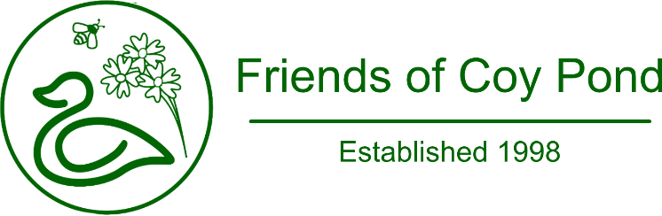
Membership Form
Date
First name(s)
Surname
Address
Postcode
Email address
Home Tel
Mobile Tel
If you will be joining the gardening activities, please provide the following information:
Emergency Contact
Name
Telephone
Membership Fee
We ask for a one-time joining fee, per household of £10.

Membership Fee Payment
This can either be paid direct by Bank Transfer to:
Account name | Friends of Coy Pond
Sort code | 30-99-50 (Lloyds)
Account number | 32062963
Or by cheque, payable to “Friends of Coy Pond” together with this Membership Form to:
Mr Wayne Hancock,
Treasurer, Friends of Coy Pond
Flat 60, The Oasis,
45 Lindsay Road,
Poole,
Dorset.
BH13 6AP

